# CHAPTER FOUR: SYSTEM ANALYSIS AND DESIGN

# 4.1 INTRODUCTION

This chapter describes the feasibility analysis, functional and non-functional requirements result of the interview analysis and design of the Kilimo Cha Maziwa Mobile Application. It involves feasibility analysis, functional and non-functional requirements and UML diagrams. The designed UML diagrams represent the system, its flow and the expected interactions with the various users.

# 4.2 FEASIBILITY ANALYSIS

# 4.2.1 Technical Feasibility

We carried out a technical feasibility analysis to find out whether the existing technology supports the proposed mobile application. Due to growing use of smart phones, the technology used in development of the Kilimo Cha Maziwa App is supported by most of the Android devices available to the farmer. Also due to high growth of the smart phones, most farmers have become literate on how to operate their phones hence they are highly unlikely to experience difficulties while using the mobile App.

# 4.2.2 Operational feasibility

We carried out this study to find out how well the mobile application will deliver the operations needed efficiently. We ensured sufficient storage and processing capability of the server to ensure that the system has good operational capability. This included ways of how to handle network errors while a transaction is happening.

# 4.2.3 Economic Feasibility

We examined the cost incurred and the benefit. It involves the cost incurred for the resources required for development. The mobile application though it doesn’t generate income, it saves resources such as time and ensures dependability and efficiency of the Dairy farmer’s data that will lead to the generation of his or her income.

# 4.3 Requirement Analysis

A requirement is a description of features and functionalities of the target system Requirements analysis is the process of developing software specifications that are intended to communicate the system needs of the customer to the system developers. It involves determining the user expectations for the system. It can be classified as either functional or non-functional requirements.

# 4.3.1 Functional Requirements

These requirements specify the functions that the system is expected to perform.

They included the following:

1. To allow a user to sign up and login to the account in the mobile application.
2. To allow the dairy farmer to input the daily milk records sold in the mobile application.
3. To allow the dairy farmer generate reports of each transaction made to the database.
4. To allow dairy farmer contact the Vet inside the mobile application.
5. To allow the Vet locate the geolocation of the farmer.
6. Allow the dairy farmer apply for the Maziwa Mingi Loan.

# 4.3.2 Non-Functional Requirements

1. Reliability -The mobile application ensures minimum failure, and the rate of occurrence of failures for instance in the case of Network errors.
2. Ease of use – The mobile application is easy to use for all the users involved especially because of the good user Interface and clear instructions.
3. Confidentiality – The information gathered during the authentication is confidential.
4. Availability - The services offered by the mobile application will always be available at all times needed.
5. Understandability- The mobile application is easy to understand by new users based on the user-friendly interface.
6. Performance - the response time of the mobile application to user requests. The response of the system should be fast in that it meets the user requests with minimum delay or no delay at all.

# 4.5 System Analysis

It’s a technique that divides a system into its components to understand how the components work and interact to accomplish the designed purpose.

# 4.5.1 Use case diagram

This diagram shows how actors interact with the system. There are five actors, Dairy Farmer, Manager, Vet and the App Admin. In this case the Dairy Farmer is the primary actor while the manager, vet and App admin are the secondary actors.

# 

# 4.5.2 Activity diagram

The diagram shows the flow of activities in the system. It also shows who initiates the actions performed.

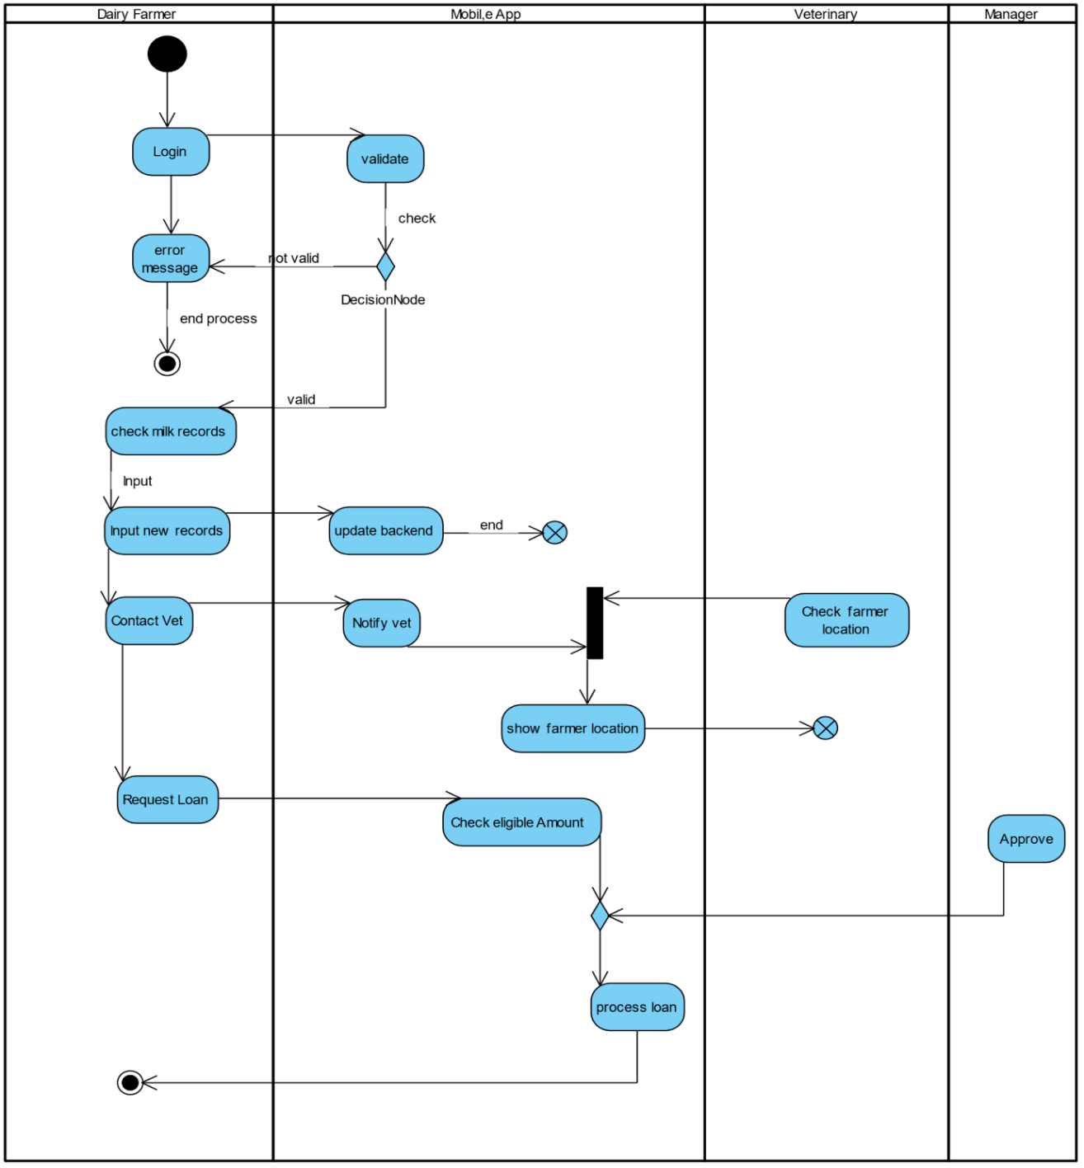

# 4.5.3 Sequence diagram

The diagram gives the sequence of activities in the system. There are five actors, Dairy Farmer, Manager, Vet and the App Admin. The different actors have different objects to interact. The diagram shows which activities precedes others for instance, updating a milk record cannot be performed before authentication of the user is done.

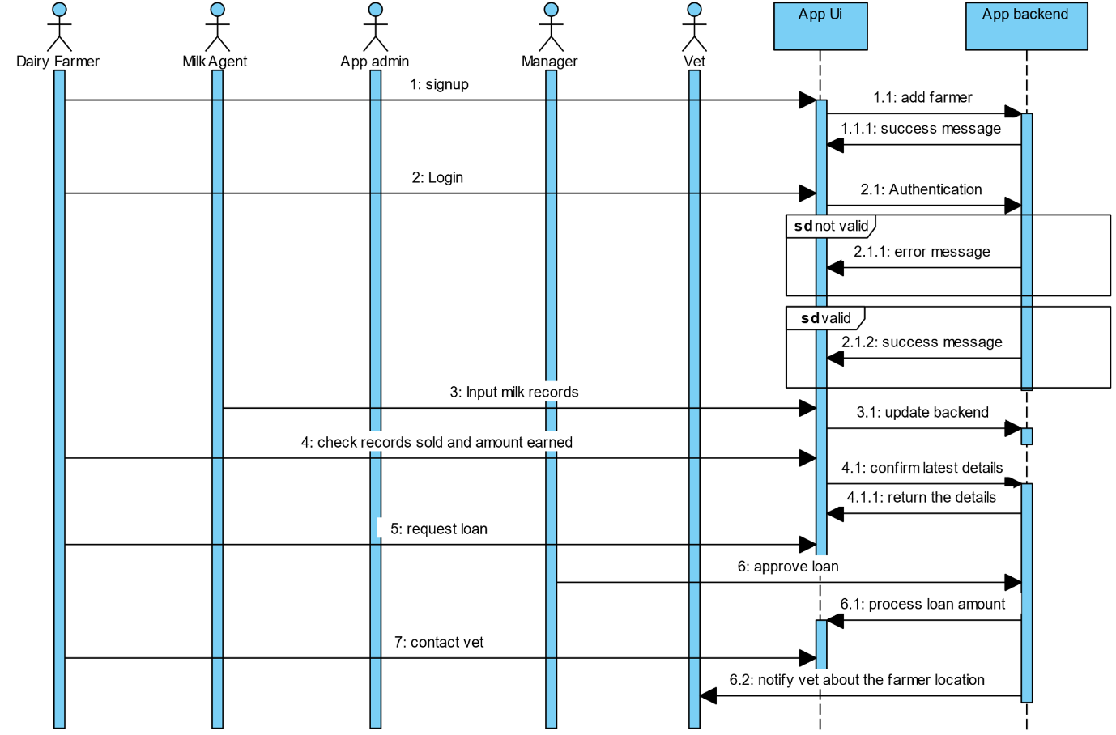

# 4.5.4 Class diagram

The diagram shows the relationship among the main classes. There are four main classes, Dairy Farmer, Vet, Manager and the App admin. For instance, many dairy farmers can contact many veterinaries and many veterinaries can provide services to many dairy farmers. This is a many to many relationship.

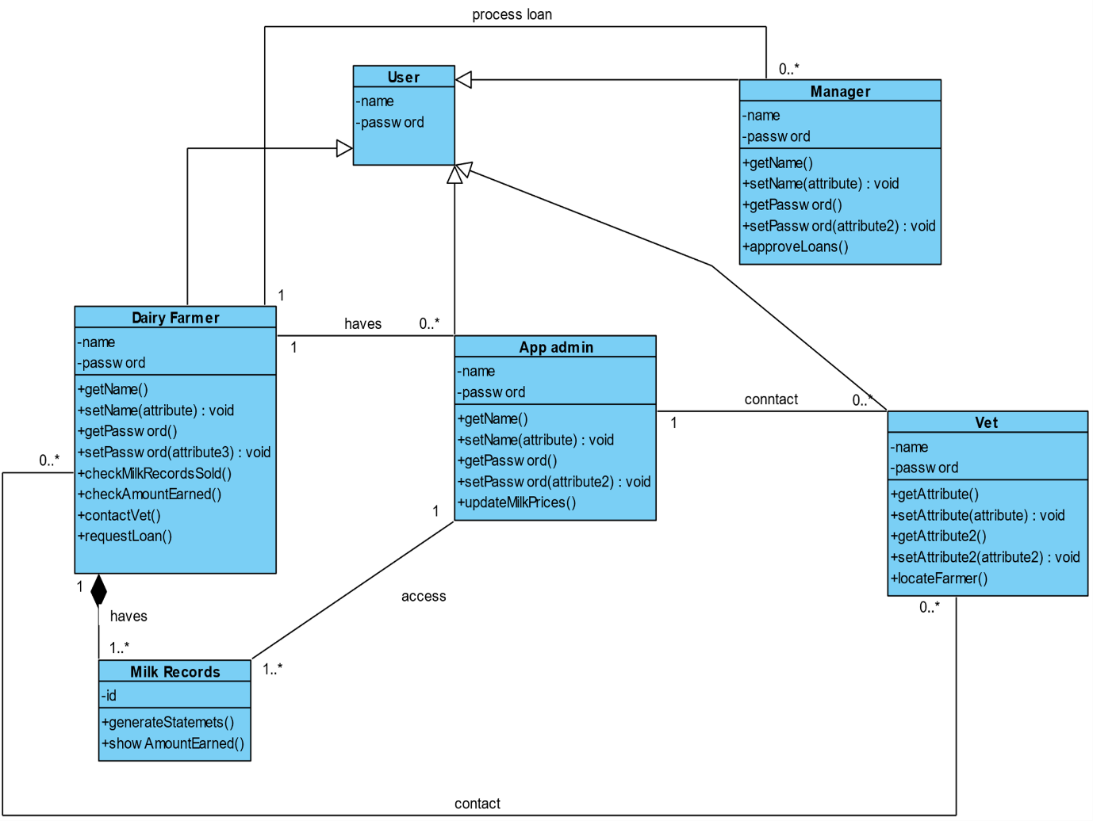

# 4.5.5 Entity Relation Diagram

The diagram shows the relationships between different entities of the database. It makes use of primary keys which are unique columns in the rows of a database and also the foreign keys which are primary keys of other tables in the database.

